

THIS IS TO CERTIFY THAT ABISHEK RANJAN S/O - HRIDYA NARAYAN RAM

BEARING REGISTRATION NO 18324 IS A BONAFIDE STUDENT OF 3’rd SEMESTER,

COMPUTER SCIENCE ENGINEERING DEPARTMENT B.TECH PROGRAMME OF THIS INSTITUTE.

HE/SHE WILL BE UPGRADED TO 4’TH SEMESTER BY SECOND YEAR (CLASSES STARTS FROM 18-01-2020).

AFTER COMPLETING USUAL ACADEMIC PROCEDURE.

HIS/HER TOTAL YEARLY FEE AT THE TIME OF REGISTRATION FOR SEMESTER RS 54,025(FIFTY FOUR THOUSAND TWENTY FIVE).

HE/SHE HAS BEEN ENROLLED UNDER YEARS B.TECH PROGRAMME ONLY OF THE INSTUTE.

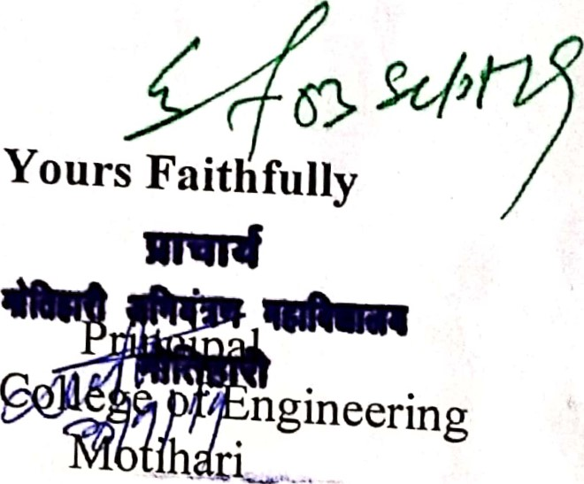

.2